solution scope document
FEDERAL Bank
PHASE 2 – Data Extension & Real-Time Enablement SSD Version 1.0

Mandar Khot
June 10, 2026
Version: 1.0

Table of contents
1. Introduction 4
1.1 Purpose 4
1.2 Reference Documents 5
1.3 Document Control 5
1.3.1 Change History 5
2. Client overview 5
2.1 Business Objectives 5
3. Proposed solution scope 6
3.1 Data Model Enhancement. 6
3.1.1 Data Model Enhancement 6
3.2 Detailed Message Enrichment Logic 8
3.2.1 Enrichment Objective 8
3.2.2 High-Level Enrichment Flow (Bank → PRM Responsibility) 8
3.2.3 Channel-wise Enrichment Logic. 12
3.2.4 Enrichment Configuration in PRM 13
3.2.5 Handling Scenarios 16
3.2.6 Data Consistency Rules 18
3.2.7 Dependency on Source Systems (Bank responsibility) 18
3.2.8 Outcome of Enrichment 20
3.3 System Architecture: - 21
3.4 Data Flow Summary: - 22
3.5 Proposed Solution Context Diagram 24
3.6 Volume considerations 26
3.7 Proposed Hardware 27
4. Implementation Considerations/Pre-checks 27
4.1 Infrastructure Readiness 27
4.2 Data Load & Update Setup 28
4.2.1 Bank Responsibility (Upstream Source Systems) 28
4.2.2 PRM Responsibility (Consumption Only) 30
4.3 PRM Table & Rule Configuration 30
5. aci project considerations 31
5.1 Risks 31
5.2 Recommendations 34
5.3 Assumptions 36

Introduction

Purpose
This document is intended to portray relevant information about a proposed initiative for Federal Bank. It is reflective of discussion and informal agreement that has taken place between ACI and Federal Bank prior to involvement of a project team. Primary sections in this document include:
Client Overview – this section is a brief narrative about Federal Bank, their business objectives for this initiative, the status of the opportunity, and next steps for the engagement.
Current Business Processing Description – this section briefly describes Federal Bank’s current processing environment and includes a context diagram of their system along with current product and hardware details.
Proposed Solution Scope – this section summarizes the scope of the proposed solution as pertains to ACI products and/or services. It includes a high-level solution diagram (context diagram), an indication of the proposed platform, any known client specific modifications (CSM) to the software, any known implementation considerations, and any relevant references to future initiatives.
Business Drivers – this section outlines Federal Bank’s reasons for undertaking the initiative and any known risks, costs, or limitations.
Project Sponsors and Budgets – this section makes reference to the organization within Federal Bank’s hierarchy that is responsible for the project and any pertinent information about the budget for the project.
ACI Team – this section outlines the ACI representatives that have been engaged with Federal Bank thus far in the initiative.
Document Acceptance – this section serves to indicate Federal Bank’s agreement as to the accuracy of this document.

Reference Documents
Name | Source | Document
 | Email

Document Control
A description of the document revisions is shown below. Any changes of text from one version to another are indicated with the symbol “|” in the outside margin.

Change History
Name | Date | Version | Description of Changes
ACI Worldwide Pvt Ltd | 10-June-26 | 1.0 | Initial version

Client overview
Federal Bank is the preferred Personal, NRI and Business banking partner for a growing expanse of customers across India, in both urban and rural areas. The Bank is driven by the quest to be one of the most admired banking institutions in the country. This is just one manifestation of the Bank’s powerful ‘Digital at the Fore, Human at the Core’ proposition. Redefining human experience, the digital way has been our constant goal for a while now. Our digital innovations of today are on the cusp of redefining the banking paradigm of tomorrow. Federal Bank is continuously scaling up this mantra to reach out, meaningfully and impactfully, to more customers. Recognized as a Great Place to Work, the Bank is continuously striving to become the FIRST CHOICE for all Indians. Propelling this journey is our unwavering focus on the service of People, within and outside the organization.

Business Objectives
The objective of Phase‑2 is to enable effective utilization of customer demographic data within transaction processing by establishing a link between transaction data and customer identity in the PRM system.
Following the successful onboarding of customer and card demographic data in Phase‑1, this phase focuses on enriching incoming transactions with Customer ID by mapping it to the User Account Number (UAN), which serves as the primary customer identifier within PRM.
This enrichment enables PRM to process transactions in a customer-centric manner, thereby improving fraud detection effectiveness across channels such as Debit Card, UPI, and IMPS.
Phase‑2 focuses on transitioning PRM from a data-ready state to a data-driven fraud detection system by ensuring that all transactions are enriched with customer identity, enabling effective and unified monitoring across channels.

Proposed solution scope
Phase‑2 focuses on enabling the utilization of customer demographic data within transaction processing by implementing transaction enrichment and customer-level identification in PRM.
The proposed solution includes enhancements in data model, transaction processing, and enrichment logic to ensure that all incoming transactions are mapped to the corresponding customer identifier within PRM.

Data Model Enhancement.

Data Model Enhancement
To enable customer-centric processing in PRM, the existing data model will be extended to introduce User Account Number (UAN) as the primary customer identifier. UAN will serve as the standard dimension within PRM for representing customer entities and linking transactions across channels.
1. Introduction of UAN in PRM Data Model
- PRM supports Customer (UAN) as a core dimension used for:
  - Grouping transactions
  - Performing customer-level rule evaluation
- As part of Phase-2:
  - PRM will be configured to use UAN dimension for customer identification
  - UAN will act as the logical representation of Customer ID within PRM
- No new physical database tables are required:
  - PRM already maintains UAN-related structures internally
  - Configuration will ensure consistent usage of the UAN dimension across processing
2. Extension of CDIF / Transaction Data Model
- Incoming transaction messages (CDIF / IF / PIM structures) will be extended to include:
  - UAN field (Customer identifier field)
- This enhancement ensures:
  - Every transaction processed in PRM contains a customer reference (UAN)
  - Transactions can be linked across:
    - Card transactions
    - Account-based transactions
    - Multiple channels (BASE24, UPI, IMPS)
3. Customer ID to UAN Mapping (Logical Representation)
- Bank-provided Customer ID will be logically mapped to the UAN field within PRM.
- As per source system data structures:
  - SM_USER_ID represents Customer ID in Card domain (RT_CARD_MASTER)
  - SM_UAN represents Customer ID in Account / UAID dimensions
- PRM will be configured to map these attributes to the UAN field within the transaction data model.
Note:
The detailed look up and enrichment mechanism for mapping Customer ID to UAN is implemented during transaction processing and is described in Section 3.2.4 (Transaction Message Enrichment).
4. Storage and Referencing of UAN in PRM
- Once populated, UAN will be persisted and used across PRM processing components, including:
  - RT_ShortWindow tables (real-time transaction processing context)
  - Transaction processing pipeline
  - Profile and Enhanced Profile tables
  - Rule evaluation procedures
- UAN will be associated with:
  - Transactions
  - Alerts
  - Customer-level profiles
- Enabled Capabilities
- Customer-level transaction aggregation
- Cross-channel transaction linkage
- Customer-centric rule execution
5. Consistent Usage Across PRM Dimensions
- UAN will be used as the standard controlling key across:
  - Rules
  - Aggregation logic
  - Profile management
- All channels (CARD, UPI, IMPS) will utilize UAN as the common customer identifier within PRM.

6. Dependency on Source Data (Bank team responsibility)
- As PRM relies on Customer ID values provided by upstream Bank systems.
- PRM will:
  - Use Customer ID for UAN population
  - Not generate or modify Customer ID values
- Data accuracy, consistency, and mapping integrity remain the responsibility completely of upstream Bank systems.
7. Outcome of Data Model Enhancement
- After implementation:
  - UAN will be available in transaction processing context for all enriched transactions
- This enables PRM to:
  - Perform customer-level monitoring
  - Support cross-channel transaction analysis
  - Utilize customer-level attributes for rule execution

Detailed Message Enrichment Logic
Message Enrichment is the core component of Phase-2, where incoming transactions are enriched with customer information by mapping Customer ID to User Account Number (UAN) within PRM.
This process ensures that all transactions processed in real-time (RT) and near real-time (NRT) are associated with a customer identifier, enabling customer-centric processing and monitoring.

Enrichment Objective
The objective of message enrichment is to:
- Associate each transaction with a Customer ID
- Map Customer ID to UAN (PRM internal customer dimension)
- Enable consistent customer identification across:
  - Debit Card transactions
  - UPI transactions
  - IMPS transactions

High-Level Enrichment Flow (Bank → PRM Responsibility)
The enrichment process follows the below logical steps:
- Transaction Ingestion
PRM receives transaction messages through configured inbound interfaces (AG/IF/PIM), supporting both real-time (RT) and near real-time (NRT) processing.
Supported source systems include:
- BASE24 (Card transaction interface)
- UPI switch interface
- IMPS transaction interface
Transactions are ingested into PRM via:
- Defined record sources
- Configured message formats (e.g., CDIF / PIM structures)
At this stage, transactions contain transactional attributes only, without customer-level identification.
- Identifier Extraction
During the initial parsing stage, PRM extracts key identifying fields from the incoming transaction payload.
- PRM extracts and maps identifiers:
  - PAN → SM_PAN (Card transactions)
  - Account Number / Reference ID → SM_PRI_ACCT_NUM / SM_USER_ACCT_ID (UPI/IMPS)
- Primary Account Number (PAN) for card-based transactions
- Account Number / Reference ID / Virtual ID for UPI and IMPS transactions
These identifiers act as lookup keys for enrichment processing.
- The extraction is handled through:
  - Record Source field mappings
  - Input field-to-attribute configuration within PRM
- Customer Lookup (RT_CARD_MASTER)
- PRM performs a real-time lookup operation using identifiers extracted from the incoming transaction payload via configured record source mappings.
- Extracted identifiers include:
  - Primary Account Number (PAN) for card transactions
  - Account Number / Reference ID for UPI and IMPS transactions
  - SM_PAN → RT_CARD_MASTER → SM_USER_ID
  - SM_PRI_ACCT_NUM / SM_USER_ACCT_ID → Account Mapping Dataset → SM_UAN
- These identifiers are used as lookup keys against the reference dataset:
  - RT_CARD_MASTER (or equivalent dataset maintained by the Bank)

- Lookup Logic
Transaction Identifier (PAN / Account No)
↓
RT_CARD_MASTER Lookup
↓
Customer ID Retrieval

- Customer ID → UAN Mapping
- Once Customer ID is retrieved, PRM enrichment logic performs a field-level transformation and assignment.
- Logical mapping:
Customer ID (Source Attribute) → UAN (PRM Customer Dimension)
- UAN field is populated dynamically within the transaction context.
- This mapping is implemented using:
  - Message Enrichment configuration
  - Attribute-to-dimension mapping rules
- UAN becomes the primary key for customer-level processing within PRM.

- Transaction Update (Enriched Record Creation)
- After enrichment, PRM updates the transaction record by appending:
  - UAN (Customer Identifier)
  - Additional enrichment attributes (if configured)
- The enriched transaction is now:
  - Fully normalized for PRM processing
  - Linked to a customer dimension
- This enriched dataset is committed within:
  - Transaction processing pipeline (ShortWindow context)
  - In-memory processing layer for rule execution
- Downstream Processing
- The enriched transaction is forwarded to core PRM processing components:
a) Rule Engine Execution
- Rules are evaluated using:
  - Transaction attributes
  - Customer-level (UAN-based) context
b) Alert Generation
- Alerts, if triggered, are:
  - Associated with UAN
c) Profile / Enhanced Profile Updates
- Transaction details are:
  - Aggregated at UAN level
  - Stored for behavioral and velocity analysis
- End-to-End Logical Representation important
Transaction (CARD / UPI / IMPS)
↓
PRM Ingestion (Record Source)
↓
Identifier Extraction (PAN / Account)
↓
Lookup (RT_CARD_MASTER)
↓
Customer ID Retrieved
↓
Mapping → UAN
↓
Enriched Transaction
↓
Rule Evaluation → Alert → Profile Update

Channel-wise Enrichment Logic.
The enrichment logic is applied across all supported transaction channels. While the overall enrichment approach remains consistent, the lookup key and identifier extraction differ based on the transaction source and message structure.
For each channel, PRM uses the extracted transaction identifier to perform a lookup, retrieve the Customer ID, and populate the UAN field.
A. Debit Card Transactions (BASE24)
Input Identification
- Primary identifier:
  - Primary Account Number (PAN) (Card Number)
- The PAN is extracted from the incoming BASE24 transaction message using configured record source mappings.
Lookup Mechanism
- The extracted PAN is used as a lookup key against:
  - RT_CARD_MASTER
(SM_PAN → RT_CARD_MASTER → SM_USER_ID
SM_PRI_ACCT_NUM → Account Master → SM_UAN)

Customer ID retrieved as SM_USER_ID (Card) or SM_UAN (Account) will be mapped to UAN.
Enrichment Processing
- PRM performs:
  - Lookup of Customer ID based on PAN
  - Retrieval of any additional attributes (if configured)
- Enrichment logic then:
  - Maps Customer ID → UAN
  - Populates UAN within the transaction context
Outcome
- Each card transaction is:
  - Linked to a customer (UAN)
  - Available for customer-level rule evaluation and monitoring
B. UPI Transactions
Input Identification
- Identifiers may vary based on message structure:
  - Account Number
  - Virtual Payment Address (VPA)
  - Reference ID / Transaction ID (if mapped)
- These identifiers are extracted from the incoming UPI transaction payload using record source configuration.

Lookup Mechanism
- Extracted identifier is used to resolve Customer ID via:
  - Account-to-customer mapping dataset (RT_CARD_MASTER or equivalent)
- SM_PRI_ACCT_NUM / SM_USER_ACCT_ID → Account Dataset → SM_UAN

Enrichment Processing
- PRM performs:
  - Lookup to retrieve Customer ID
  - Mapping of Customer ID → UAN
- Additional enrichment attributes may be populated if configured.
Outcome
- UPI transactions are:
  - Associated with a UAN
  - Enabled for customer-level tracking across channels

C. IMPS Transactions
Input Identification
- Primary identifiers include:
  - Account Number
  - Customer reference identifiers (if available)
- These fields are extracted using PRM record source mappings.
Lookup Mechanism
- Extracted identifier is used for lookup:
Account Number → Lookup Dataset → Customer ID
SM_PRI_ACCT_NUM → Account Dataset → SM_UAN
- Lookup source:
  - RT_CARD_MASTER (if extended for account mapping)
  - OR other bank-provided reference dataset
Enrichment Processing
- PRM performs:
  - Retrieval of Customer ID
  - Mapping of Customer ID → UAN
- Enrichment ensures consistency with card and UPI flows.
Outcome
- IMPS transactions are:
  - Linked to a UAN
  - Included in unified customer-level monitoring

Enrichment Configuration in PRM
The transaction enrichment functionality in PRM will be implemented using a combination of Record Source configuration and Message Enrichment logic, which define how incoming transaction messages are parsed, transformed, and augmented with customer-level attributes.
PRM provides configurable message processing capabilities that allow field-level mapping, lookup, and transformation during transaction ingestion

A. Record Source Configuration
- Each transaction channel (CARD, UPI, IMPS) is associated with a defined Record Source within PRM.
- Record Source configuration is used to:
  - Parse incoming transaction payloads (CDIF / PIM / IF structures)
  - Map input fields to corresponding PRM internal attributes
- Key mapping activities include:
  - Mapping PAN / Account Identifier → PRM transaction attributes
  - Defining the fields that will act as lookup keys for enrichment
B. Input Field Mapping
- Input fields received from source systems are mapped to PRM attributes using configurable field mappings.
- Examples of input field mappings:
  - Card Number → SM_PAN
  - Account Number → SM_PRI_ACCT_NUM / SM_USER_ACCT_ID
  - Customer ID → SM_USER_ID (Card) / SM_UAN (Account)
- PRM will be configured to use SM_PAN and SM_PRI_ACCT_NUM as lookup keys, retrieve Customer ID (SM_USER_ID / SM_UAN), and populate the same into the UAN field within transaction processing.
- These mapped attributes are then used for:
  - Lookup processing
  - Further enrichment logic

C. Lookup Configuration
- PRM enrichment configuration defines lookup logic against external reference datasets, primarily:
  - RT_CARD_MASTER
- Lookup configuration includes:
  - Defining lookup key fields (e.g., SM_PAN, SM_PRI_ACCT_NUM)
  - Mapping lookup result fields to PRM attributes

- D. Enrichment Logic Configuration
- Message Enrichment logic performs attribute-level transformation and assignment during transaction processing.
- Enrichment configuration maps:
Customer ID → UAN (SM_USER_ID / SM_UAN → UAN)
- This is implemented using:
  - Attribute mapping rules within PRM configuration
  - Field assignment logic defined in message enrichment setup
- UAN is dynamically populated at runtime for each transaction.
E. Output Attribute Population
- After completion of enrichment:
  - The transaction is updated with:
    - UAN (Customer Identifier)
    - Additional attributes retrieved from lookup (if configured), such as:
      - Customer segment
      - Risk category
      - Account linkage
- The enriched attributes become part of:
  - Transaction context (RT_ShortWindow)
  - Rule evaluation inputs
  - Profile and aggregation processing

F. Processing Characteristics
- Enrichment is executed:
  - Inline during transaction ingestion
  - Within the real-time processing pipeline
- The process is:
  - Fully configuration-driven
  - Non-intrusive (no modification of source data)
  - Dependent on lookup data availability
G. Error Handling and Controls (Optional but Recommended)
- In case lookup fails:
  - UAN may remain null or default (based on configuration)
- PRM does not:
  - Generate Customer ID
  - Perform data correction
- Validation of mapping and data accuracy remains with:
  - Bank / source systems
Summary :

The enrichment configuration in PRM leverages Record Source mappings and Message Enrichment logic to perform field-level transformation and lookup-driven attribute population, enabling dynamic assignment of Customer ID to UAN during transaction processing.

Handling Scenarios
Following the execution of message enrichment within PRM, the system will handle different scenarios based on the outcome of lookup and mapping operations. These scenarios define how transactions are processed under varying data availability conditions.
1. Successful Enrichment
- Condition:
Customer ID is successfully retrieved from RT_CARD_MASTER (or equivalent reference dataset)
- Processing:
  - PRM will populate UAN with the retrieved Customer ID
  - Transaction will be considered successfully enriched
- Outcome:
  - Rule evaluation will use both: Transaction attributes, Customer-level (UAN-based) context
  - Alerts and profile updates will be associated at the customer (UAN) level

2. Customer ID Not Found (Lookup Failure)
- Condition:
No matching record found in lookup dataset
- Processing:
  - UAN will remain NULL or default (if configured)
  - PRM will not attempt any fallback derivation or inference
- Handling (configurable -Driven):
  - Transaction will continue processing at transaction level
  - Optional flagging may be enabled for monitoring or audit purposes
- Impact:
  - Transaction will not participate in: Customer-level profiling, Customer-based aggregation or analysis
3. Multiple Mapping Scenario
- Condition:
Multiple Customer IDs are associated with a given identifier
- Processing:
  - PRM will not perform conflict resolution
  - PRM assumes pre-resolved and deterministic mapping from source systems
- Outcome:
  - Resolved Customer ID will be mapped to UAN
  - Transaction processing will continue using the mapped UAN
Summary
PRM handles enrichment scenarios based on the availability and accuracy of lookup data, ensuring that transactions are processed consistently while relying on upstream systems for data correctness. Successful enrichment enables customer-level processing, while fallback scenarios allow continued transaction processing with reduced context.

Data Consistency Rules
To ensure accurate and deterministic enrichment, the following data consistency rules must be maintained:
- Deterministic Customer Mapping:
A given Customer ID will always be mapped to a single and consistent UAN across all transactions.
- Cross-Channel Consistency:
Customer ID mapping must remain consistent across:
  - All supported channels (CARD, UPI, IMPS)
  - All transaction types and processing flows
- Identifier Consistency:
Source identifiers (e.g., PAN, Account Number) must consistently resolve to the same Customer ID in the reference dataset (RT_CARD_MASTER or equivalent).
- Mapping consistency must be maintained for:
- SM_PAN → SM_USER_ID
- SM_PRI_ACCT_NUM → SM_UAN

Summary
PRM relies on upstream data consistency to ensure correct Customer ID to UAN mapping. Any inconsistencies in source data will directly impact enrichment accuracy and must be addressed at the source system level.

Dependency on Source Systems (Bank responsibility)
The message enrichment process in PRM is dependent on the availability, accuracy, and consistency of data provided by upstream source systems only.
Bank Responsibilities mentioned below:
- Reference Data Availability:
Ensure continuous availability of the lookup dataset, primarily:
  - RT_CARD_MASTER (or equivalent reference source), accessible during transaction processing
- Mapping Accuracy:
Ensure correct and consistent mapping of:
  - Card Number (PAN) → Customer ID
  - Account Number / Identifier → Customer ID
- Data Synchronization:
Ensure that all updates to customer and card/account mappings are:
  - Reflected in the reference dataset
  - Made available to PRM in real-time or near real-time
PRM lookup depends on:
  - - SM_PAN (Card transactions)
  - - SM_PRI_ACCT_NUM (Account transactions)
PRM Dependency Statement
- PRM will:
  - Perform lookup and enrichment based on available reference data
  - Populate UAN only when Customer ID is successfully retrieved
- PRM will not:
  - Compensate for missing or delayed source data
  - Perform reconciliation or correction of mapping inconsistencies
Bank team to Confirm the following points:
- Source system responsible for maintaining RT_CARD_MASTER (or equivalent dataset)
- Whether SM_USER_ID (Card) and SM_UAN (Account) represent the same Customer ID across all systems
- -Whether RT_CARD_MASTER contains account-level mapping or separate dataset will be used
- Final lookup source for UPI and IMPS transactions
- Availability of lookup dataset (real-time / near real-time)
- Completeness and coverage of mapping:
  - PAN → Customer ID
  - Account → Customer ID

- Handling approach for:
  - Missing mappings
  - Duplicate or conflicting Customer ID scenarios

Summary
The success of enrichment in PRM is directly dependent on the quality and availability of data provided by the Bank. PRM acts as a consuming system and relies entirely on upstream systems for accurate and consistent customer mapping.

Outcome of Enrichment
- Upon successful implementation of message enrichment, PRM will be configured to associate all eligible transactions with a customer identifier (UAN), enabling customer-centric processing.
Transaction-Level Outcome
- All transactions with successful lookup will have:
  - UAN populated (mapped from Customer ID)
- Transactions without successful lookup will:
  - Continuing processing without UAN, based on configured handling
System Capability Enabled
- PRM will be capable of:
  - Performing customer-level transaction processing using UAN
  - Associating alerts and profiles at the customer (UAN) level
  - Supporting consistent customer identification across channels
Summary
Phase-2 enables PRM to transition from transaction-level processing to customer-centric processing by ensuring consistent Customer ID to UAN mapping across all enriched transactions.

System Architecture: -
The Phase-2 architecture enables customer-centric transaction processing in PRM by introducing message enrichment and Customer ID to UAN mapping within the transaction processing flow.
The architecture integrates upstream transaction sources, reference data (RT_CARD_MASTER), and PRM processing components to ensure real-time enrichment and downstream processing.
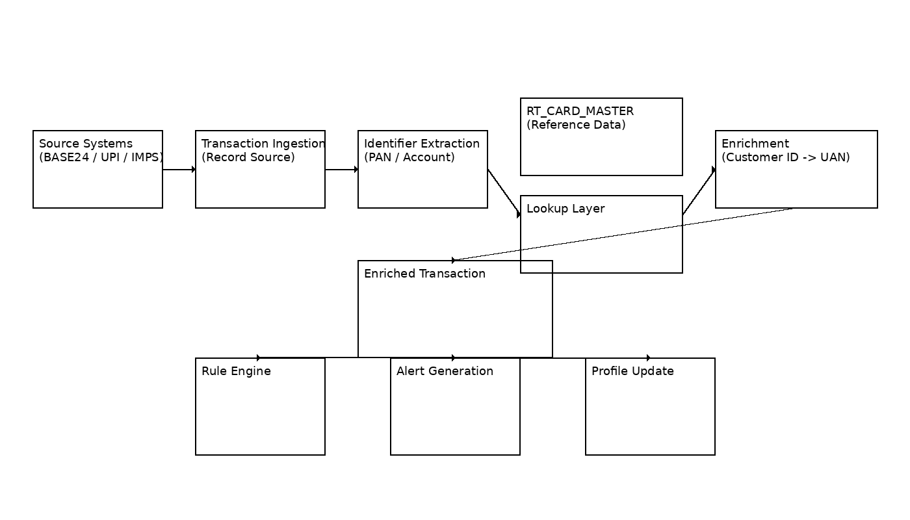
Identifier extraction layer uses:
- SM_PAN (Card)
- SM_PRI_ACCT_NUM (Account)

Lookup retrieves:
- SM_USER_ID / SM_UAN which is mapped to UAN

Data Flow Summary: -
The data flow in Phase‑2 represents the end‑to‑end processing of transactions from source systems through PRM, including identifier extraction, lookup, enrichment, and downstream processing.
Stepwise Data Flow
1. Transaction Initiation (Source Systems)
- Transactions are generated from upstream systems:
  - BASE24 (Debit Card transactions)
  - UPI switch
  - IMPS system
2. Transaction Ingestion in PRM
- Transactions are received in PRM via configured Record Source interfaces.
- Incoming messages are parsed and mapped to PRM internal attributes.
3. Identifier Extraction
- Key identifiers are extracted and mapped to PRM attributes:
  - PAN → SM_PAN (Card transactions)
  - Account Number / Reference ID → SM_PRI_ACCT_NUM / SM_USER_ACCT_ID (UPI/IMPS)
- These attributes are used as lookup keys for enrichment.
4. Lookup Execution (Reference Data Layer)
- PRM performs a real-time lookup using:
SM_PAN → RT_CARD_MASTER → SM_USER_ID
SM_PRI_ACCT_NUM / SM_USER_ACCT_ID → Account/Reference Dataset → SM_UAN
- Customer ID is retrieves as :
  - SM_USER_ID for Card transactions
  - SM_UAN for Account-based transactions
5. Message Enrichment (Customer ID → UAN Mapping)
- PRM enrichment logic performs:
SM_USER_ID / SM_UAN → UAN
- UAN is populated dynamically within the transaction processing context.
- Additional enrichment attributes may be appended if configured.
6. Enriched Transaction Creation
- Transaction is updated with:
  - UAN (Customer identifier)
  - Enriched attributes
- The transaction is made available for downstream PRM processing.
7. Rule Evaluation and Processing
- The enriched transaction is processed by the PRM rule engine using
  - Transaction attributes
  - Customer-level (UAN-based) context

8. Alert Generation and Profile Update
- Alerts (if triggered) are generated and associated with:
  - Customer (UAN)
- Transaction data is used for:
  - Customer-level profiling
  - Aggregation and monitoring

9. Exception Flow
- If Customer ID is not available during lookup:
  - UAN will remain NULL / default (if configured)
  - Transaction will continue processing at transaction level
10. Summary
The Phase‑2 data flow ensures that transactions are enriched with Customer ID (SM_USER_ID / SM_UAN) and mapped to UAN, enabling PRM to perform customer-level processing while maintaining transaction-level processing when enrichment is not available.

Proposed Solution Context Diagram
The Below diagram illustrates the high-level context of the Phase-2 solution, highlighting the interaction between source systems, reference data sources, and PRM processing components.
- Transactions originate from BASE24 (Cards), UPI, and IMPS systems and are sent to PRM.
- PRM performs transaction ingestion, identifier extraction, and real-time lookup using RT_CARD_MASTER.
- Retrieved Customer ID is mapped to UAN through enrichment logic.
- Enriched transactions are then processed by:
  - Rule Engine
  - Alert Generation
  - Profile Update
PRM acts as a processing and enrichment system, while data availability and mapping are maintained by Bank systems.

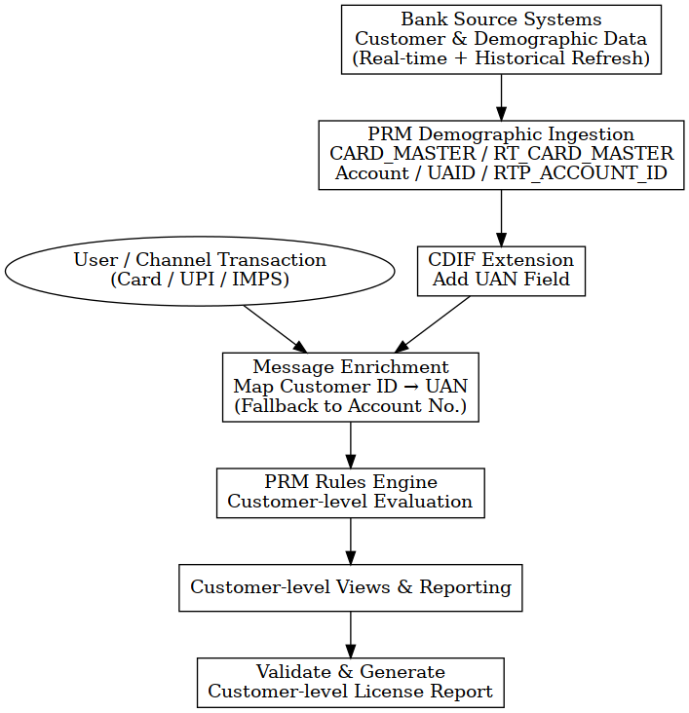

Complete Flow Diagram which is discussed with Bank team with list of interlinked Activities.
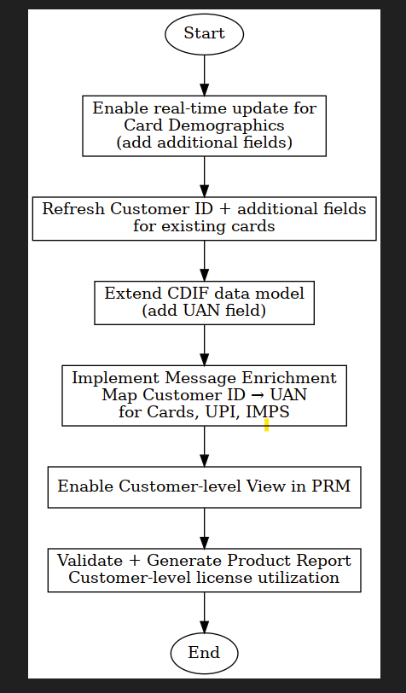

Volume considerations
The bank to confirm the volume.
Daily volume | Count

Proposed Hardware
- Bank will continue to use existing hardware in place assuming the volume of transactions will remain same.

Implementation Considerations/Pre-checks

Infrastructure Readiness
- PRM transaction processing structures must support persistence of:

- UAN (Customer identifier field) within transaction context (ShortWindow tables)
- PRM database and application environment must be sized to support incremental load generated due to:

- Customer ID enablement across Card, UPI, and IMPS channels
- Real-time transaction enrichment processing
- PRM Data Structures Validation
The following PRM tables and dimensions must be validated for readiness:
- CARD_MASTER / RT_CARD_MASTER
  - Must support lookup using:
    - SM_PAN → SM_USER_ID
- Account / UAID Dimensions
  - Must support:
    - SM_PRI_ACCT_NUM / SM_USER_ACCT_ID → SM_UAN
- Indexing Requirements
Database indexing must be validated and optimized for:
    - SM_PAN (Card lookup key)
    - SM_PRI_ACCT_NUM / SM_USER_ACCT_ID (Account lookup key)
    - UAN (Customer identifier)
This ensures:
- Low latency lookup
- Efficient enrichment execution
Note: The exact index field combinations and column order will be finalized and communicated based on the bank’s confirmation of the rule design during the implementation phase.
System Capacity
Application and DB layers must Support:
- Real-time lookup execution
- Message enrichment processing
- Customer-level rule execution
Without impacting PRM real-time SLA.

Data Load & Update Setup

Bank Responsibility (Upstream Source Systems)
1 Bank systems are responsible for ensuring availability, consistency, and correctness of Customer ID and mapping data and correctness of:
- Customer ID fields:
SM_USER_ID (Card Master)
SM_UAN (Account Master)
- Mapping Readiness
2. Bank must ensure consistent and deterministic mapping:
- SM_PAN → SM_USER_ID
- SM_PRI_ACCT_NUM / SM_USER_ACCT_ID → SM_UAN
3. Data Provisioning
- Initial Load (Baseline)
- One-time data load for:
  - All active cards (RT_CARD_MASTER population)
  - All eligible accounts
4. Incremental Updates
- Real-time / near real-time updates must include:
  - New cards / accounts
  - Changes in Customer ID mappings
  - Updates to demographic attributes

5. Data Availability Requirement
- Mapping data must be available in:
  - RT_CARD_MASTER (Card)
  - Account / reference dataset (for UPI/IMPS)
- Data must be:
  - Available before transaction processing
  - Accessible for lookup during enrichment
6. Data Ownership
- All corrections related to:
  - Customer ID mapping
  - Data inconsistencies
must be handled only by Bank systems
Bank to Confirm (Very Important)
- Whether:
  - SM_USER_ID and SM_UAN represent the same Customer ID across systems
- Final lookup dataset for UPI and IMPS transactions
- Real-time availability of : RT_CARD_MASTER
- Completeness and consistency of mapping:
  - Card → Customer
  - Account → Customer

PRM Responsibility (Consumption Only)
- PRM acts as a processing and enrichment system and consumes data as provided by upstream systems.
PRM will:
- Perform lookup using:
  - SM_PAN
  - SM_PRI_ACCT_NUM / SM_USER_ACCT_ID
- Retrieve Customer ID:
  - SM_USER_ID (Card)
  - SM_UAN (Account)
- Perform enrichment:
SM_USER_ID / SM_UAN → UAN
- Populate UAN in:
  - Transaction processing context
  - Rule evaluation layer
PRM will NOT:
- Perform validation
- Perform data correction
- Generating Customer ID
- Resolve mapping inconsistencies

PRM Table & Rule Configuration
- PRM will be configured to use:
  - UAN (Customer identifier) for all customer-level logic
Rule Configuration
Rules will:
- Use UAN for:
  - Customer-level aggregation
  - Cross-channel correlation
- Apply across:
  - CARD
  - UPI
  - IMPS
Important Constraint
- PRM rules will:
  - Consume Customer ID as provided
  - Not perform any derivation or validation

aci project considerations

Risks
The following risks are identified for Phase-2 implementation, primarily driven by dependency on upstream data quality, availability, and system performance:
1. Customer ID Availability Risk
- Incorrect or delayed publication of Customer ID from source systems (e.g., SM_USER_ID for Card, SM_UAN for Account) may result in:
  - Missing or outdated Customer ID during enrichment
  - Failure to populate UAN in transaction context
- Impact:
  - Transactions processed without customer-level identification
  - Reduced effectiveness of customer-level monitoring and reporting
2. Mapping Inconsistency Risk
- Inconsistent or missing mappings across source systems:
SM_PAN → SM_USER_ID
SM_PRI_ACCT_NUM / SM_USER_ACCT_ID → SM_UAN
may lead to:
- Incorrect UAN population
- Multiple Customer IDs for same identifier
- Fragmented customer-level aggregation across channels
3. Real-Time Data Availability Risk
- Delay or unavailability of real-time demographic updates in:
  - RT_CARD_MASTER
  - Account reference datasets
may result in:
- Lookup failure during transaction processing
- Transactions processed without enrichment (UAN = NULL)
4. Enrichment Dependency Risk
- Since enrichment execution depends entirely on lookup datasets:
  - Any missing or stale data will directly impact enrichment accuracy
- Impact:
  - Incomplete Customer ID → UAN mapping
  - Reduced cross-channel correlation capability
5. Performance & Scalability Risk
- High volume of:
  - Demographic data refresh
  - Real-time lookup operations
may impact:
- PRM database performance
- Lookup latency
- Transaction processing SLAs
Especially if indexing is not optimized on:
- SM_PAN
- SM_PRI_ACCT_NUM
- UAN
6. Data Synchronization Risk
- Delays in propagating:
  - Customer ID updates
  - Mapping corrections
from upstream systems to PRM may lead to:
- Temporary mismatch between:
  - Source systems
  - PRM transaction view
7. Dependency on Bank Systems
- PRM operates as a consuming system and does not:
  - Validate
  - Correct
  - Reconcile Customer ID data
- Any upstream issue directly impacts:
  - Enrichment
  - Rule execution
  - Reporting accuracy

Recommendations
1. Performance & Volume Validation
- The Bank should conduct volume and performance testing considering:
  - Real-time transaction load
  - Demographic update frequency
- Testing should validate:
  - Lookup performance using:
    - SM_PAN
    - SM_PRI_ACCT_NUM
  - Enrichment execution within PRM real-time SLA
2. Pre-Go-Live Data Certification
- Prior to enabling customer-level processing, the Bank should certify:
SM_PAN → SM_USER_ID
SM_PRI_ACCT_NUM → SM_UAN
- Validation should ensure:
  - Completeness of Customer ID mapping
  - No duplicate or conflicting mappings
  - Uniform mapping across Card, UPI, and IMPS channels
3. Controlled Rollout & Validation
- It is recommended to enable enrichment in a controlled manner, with:
  - Initial validation phase (UAT / limited rollout)
  - Monitoring of UAN population in transactions
- Key checks:
  - % of transactions enriched (UAN populated)
  - Consistency across channels
4. Enrichment Monitoring & Observability
- During initial deployment, Bank should monitor:
  - Lookup success rate
  - Transactions with NULL or default UAN
- Any degradation or anomaly should be:
  - Traced back to upstream mapping or data availability
5. Stability of Reference Data Availability
- The Bank should ensure continuous availability of:
  - RT_CARD_MASTER
  - Account mapping datasets
- Data should be:
  - Available prior to transaction processing
  - Synchronized in real time or near real time
6. Rule Validation for Customer-Level Processing
- PRM rules should be validated to confirm:
  - Usage of UAN as customer identifier
  - Correct aggregation and correlation across channels
7. Post-Deployment Validation
- After go-live, it is recommended to:
  - Validate enrichment outputs against source systems
  - Verify consistency between:
    - Customer ID (SM_USER_ID / SM_UAN)
    - UAN in transaction records
Summary
The recommendations focus on ensuring data validation, controlled rollout, and monitoring of enrichment execution to achieve accurate and stable customer-level processing in PRM without impacting real-time performance.

Assumptions
- All Customer ID (CID) preparation, validation, and mapping logic will be fully handled by upstream Bank systems prior to publishing data to PRM.
- Bank will ensure that Customer ID is consistently available as:
  - SM_USER_ID for Card-related records
  - SM_UAN for Account-related records
- Bank will ensure that identifier mapping is deterministic and consistent across systems:
- SM_PAN → SM_USER_ID
- SM_PRI_ACCT_NUM / SM_USER_ACCT_ID → SM_UAN
- PRM will receive only valid, complete, and pre-validated demographic and mapping data suitable for direct consumption during transaction enrichment.
- RT_CARD_MASTER and Account reference datasets will be:
  - Continuously available
  - Updated in real-time or near real-time prior to transaction processing
- PRM will act strictly as a consuming and processing system and will not:
  - Perform Customer ID validation
  - Perform mapping correction
  - Resolve inconsistencies
- A one-time historical data load will be completed successfully for:
  - All active card records
  - All eligible account records
prior to enabling Phase-2 enrichment
- Real-time demographic updates for Card and Account data will be enabled before activating Customer ID-based transaction enrichment in PRM.
- PRM rule configuration will use only the UAN (Customer identifier) field for customer-level processing and will not rely on alternative identifiers.
- Any changes to:
  - Customer ID logic
  - Mapping rules
  - Additional fields
  - Integration mechanisms
will be managed through a formal Change Request (CR) process.

- Project implementation and Go-Live will be executed remotely only.
- Based on agreed bank confirmation Post Go-Live support will be limited to 5 days,
with 8 hours per day support window.
- Post-go-live support and transition to production support (e.g., HELP24 or equivalent) will be handled as per agreed support model and contract.

Copyright ACI Worldwide, Inc. 2026
ACI, ACI Worldwide, ACI Payments, Inc., ACI Pay, Speedpay and all ACI product/solution names are trademarks or registered trademarks of ACI Worldwide, Inc., or one of its subsidiaries, in the United States, other countries or both. Other parties’ trademarks referenced are the property of their respective owners.

